Discussion

RQ:

How does individualism and collectivism influence hedonic shopping behaviour in Virtual Reality Retail?

1. Increased
2. Role
3. Adventure

STRUCT:

1. Seamles transition with the litrev:

Ex: based on the litrev therefore individualism and collectivism have a strong influence on which hedonic motivation will be more prevalent in shopping scenarios: therefore giving us insight into how individualism and collectivism influence hedonic shopping behaviour.

1. Explain the method used : classic experiment with interviews
2. Justification: Behavioural models/ Retail book / qualitative ideas (to research)/ classic experiment textbook justification.
3. Limitations: ????

**Description of the desing or method:**

To gather data a classic experiment design has been chosen:

The experiment will follow these steps:

* Sampling
* Assignment
* Intervention
* Post-test

**Sampling:**

Subjects will be chosen from a specific age group: students.. A total of eight subjects will take part in the experiment: 4 Chinese, 4 Italians varied 50-50 in gender. None of the participant will have had previous VR experiences (to reduce previous experiences to influence the results)

**Assignment:**

To gather data two groups of different nationality will be randomly assigned and put through the Intervention according to the matrix

**Intervention:**

**App Desing:**

For the experiment two apps are required which will focus on different shopping motivation: Role and Adventure by manipulating the Virtual Environment and Interaction.

The apps will Virtually recreate a furniture showroom: the role Application will have a setting that encourages participant to buy for a family member or friend; the Adventure Application will have navigation, interaction, visual and audio features that encourage Adventure Shopping.

Apps will be in participant mother Tongue

**Adventure Application Description:**

The adventure Application’s purpose is to stimulate participants to interact and experience an adventure shopping setting in VR. Such an experience will introduce participants to the VR shopping experience since none of them have had any VR experience. The app will heaviliy focus on adventure inducing stimuli:

* Store Layout: For the store layout bright lights, bright colors and fast music were chosen as they are the most arousal inducing.
* High ceiling and slanted roof
* Products were placed in a boundling style
* Products have polymers materials/ plastic
* VR environment is interactive as particapants can view information in real time of the furniture as well as change colors

**Role Application Description:**

The role application will instead focus on role shopping stimuli as a result adventure elements are take out of the application:

* Participants are in a white space without store environment
* They will be able to browse through a menu different furniture items
* They will be given a task to simulate a role shopping scenario

**Tasks:**

**ROLE**

**ADV**

Each group will go through the task of browsing the Virtual showroom under supervision. (more precise)

In the first experiment two Chinese participant and two Italian participants (of 50-50 Gender) will undergo tasks in the Adventure App.

In the second experiment two Chinese participant and two Italian participants (of 50-50 Gender) will undergo tasks in the Role App.

|  |  |  |
| --- | --- | --- |
| APPLICATION MATRIX | Adventure APP | Role APP |
| China | CHAdv | CHRole |
| Italy | ITAdv | ITRole |

**Post-Test: (why not pre-test)**

After the virtual application task subjects will be interviewed using qualitative in-depth interviews. A series of question will be the following:

…………….

………………

In each application experiment results will be compared between Chinese subjects and Italian Subjects. This will ensure that any variable in the application can be compared against a different set of subjects of different nationality.

**Justification:**

**Sampling:**

Chinese and Italian subjects have been chosen based on scores of individualism and collectivism have great variance: China scores 80 in Collectivism while Italy scores 76 in Individualism. The two countries have similar scores in the Hofstede dimensions used for the study.(source)

Students have been chosen as this age group is the most likely to engage with this technology in the near future (source)?????? TO RESEARCH

The sampling will also take into account gender as it has been shown that there are differences in hedonic shopping motivations across different genders (SOURCE, reynolds). The study will have a 50-50 approach to gender representing both equally. This means that of the 8 people participating 4 will be male and 4 female.

**Assignment:**

Assignment will be random as prescribed in the classic experiment(source). Randomness will ensure that any change between the groups is caused by the variable being studied: i.e. Adventure Shopping or Role Shopping(which variable decide!!!!). Random assignments will be generated with a random number generator. Each participant will be assingned to an Application Type (Role or Adventure) if odd role if even adventure.

The matrix shows how experimental groups will be assigned. The core reason for using different group of nationality is that different groups will undergo the same treatment allowing the researcher to have a control group upon which to compare the results of the experiment:

For example when testing the Role Application the researcher will have both an Italian group and a Chinese group results allowing to better understand if the variable being studied has had an effect.

This approach is a further elaboration of the classic experiment control group. In this case both groups undego the application but cultural background is different

Reason for a control group:

……………………………..

……………………………..

**Intervention:**

**Application Design:**

**Adventure Application:**

The adventure application is designed to stimulate participants with a range of arousing-inducing stimuli and arousing-reducing stimuli. Adventure Shoppers seek exciting stimuli that accompany their purchases, the app is designed to cater those needs. The manipulation of stimuli is designed on the basis of the Mehrabian-Russel model.

The model assumes that there are two determinants of emotional responses in shoppers: the shopper personality and the environment.

Personality refers to the tendency of shoppers to be either

* Arousal seekers: shoppers that prefer a fast-paced, stimuli intensive store designs
* Arousal avoiders avoid exposure to high-intesity stimuli(bright lights, colors etc.) and prefer a more calming experience

Environment: environment refers to the set of all stimuli present in the store sometimes called the “information rate”. The information rate can be categorised on the dimension of novelty(how new to the shopper the environment is) and complexity(how easy or difficult is of the shopper to process store arrangements, layout etc.) The sum of all environmental stimuli is called the “information rate” .

Drivers of behaviour: Arousal and Pleasure

Arousal refers to the excitement that a store’s stimuli provoke in shoppers. Pleasure refers instead to the enjoyability of the shopping experience.

These two variables together can categorise shopping experiences into four quadrants (MATRIX).

The application is designed to cater both arousal seekers and arousal avoiders personality. The store environment aims to be placed in the far right giving a combination of low and high arousal.

To accomplish this the application contains two separate rooms: the first contains arousal-inducing stimuli which will cater arousal seekers, the second arousal reducing stimuli which will arousal avoiders.

Seekers will find arousal inducing rooms more pleasurable…

Avoiders will find arousal reducing stimuli more Pleasurable…

This strategy is taken from … 7 which consist of creating contrasting zones in a shop to balance arousal-inducing and reducing stimuli and it is designed to render the experience as pleasurable as possible to the largest amount of people.

Arousal-inducing stimuli:

Based on Ebster arousal inducing stimuli included in the first room:

1. Large space
2. bright store illumination,
3. fast music
4. High Ceiling
5. Bright colours, mostly polymers

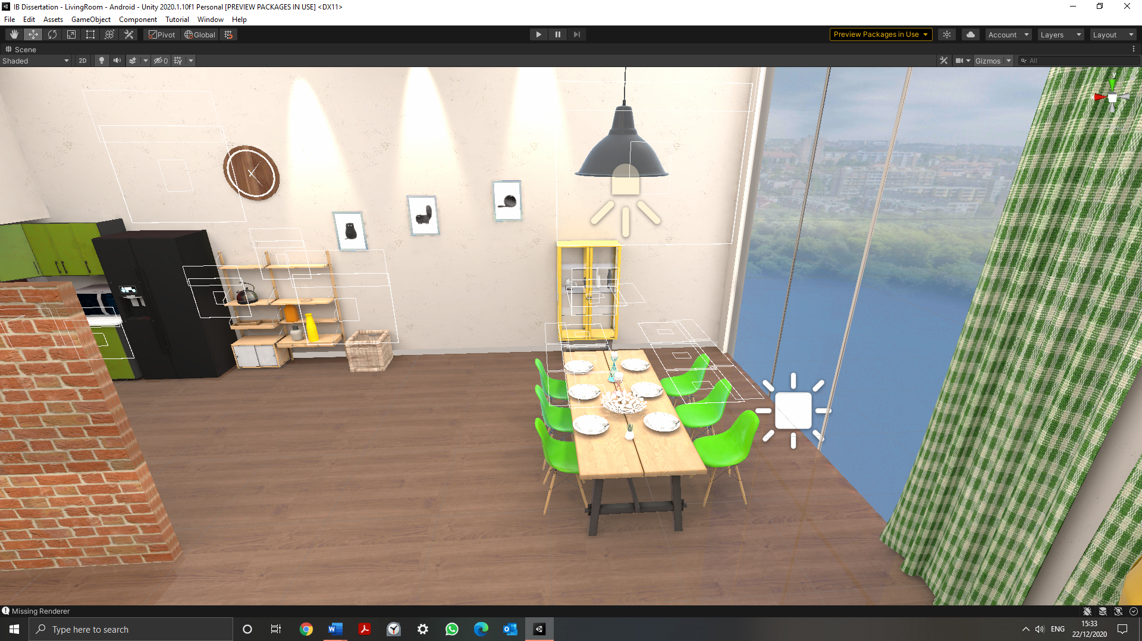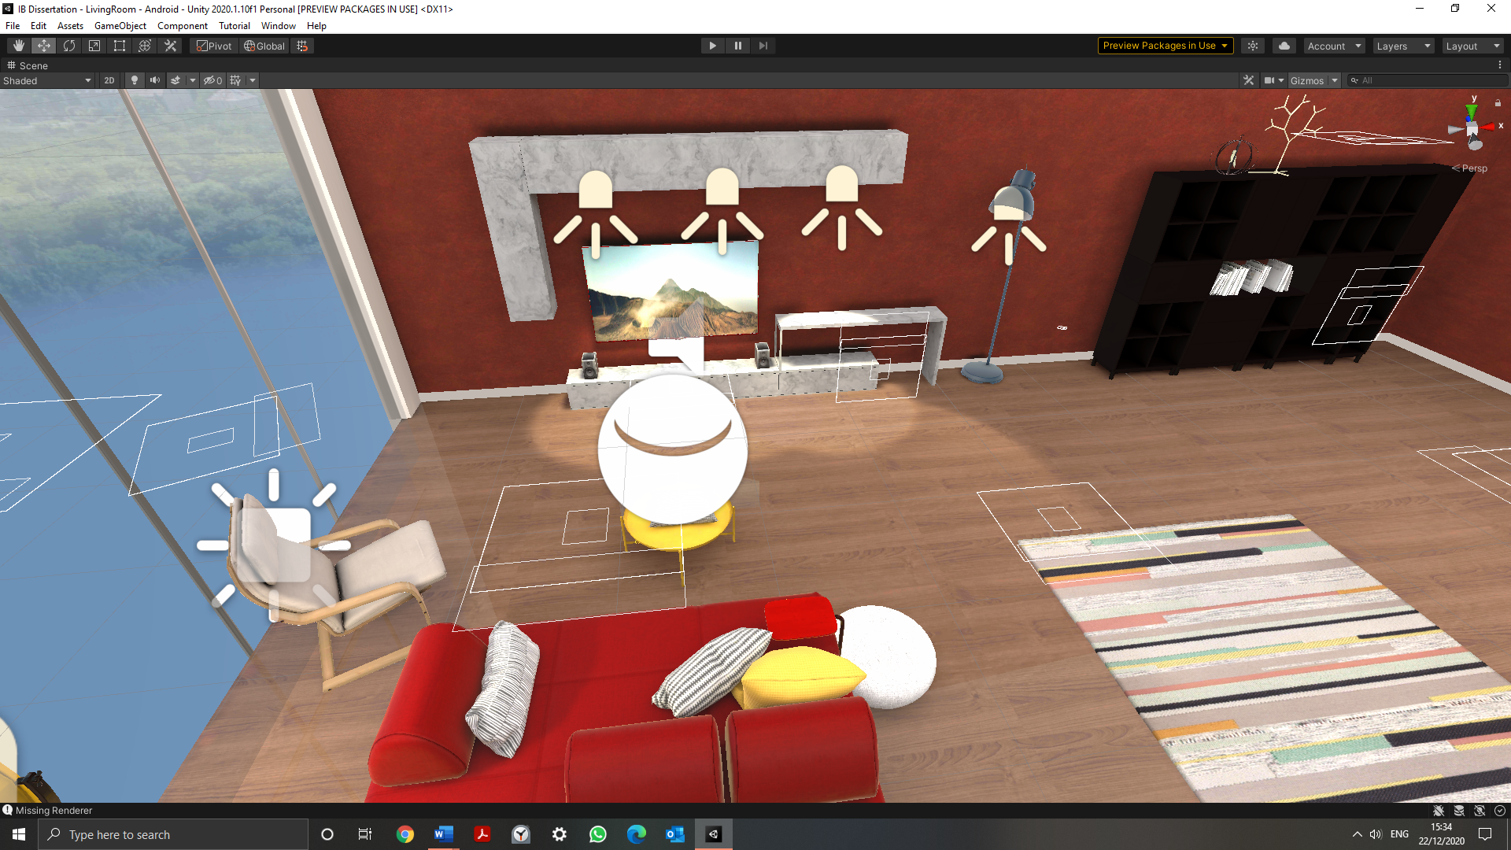

Arousal-inducing stimuli:

Based on Ebster arousal inducing stimuli included in the first room:

1. Smaller space
2. dim store illumination,
3. slow music
4. low Ceiling
5. tame colours, mostly cloth

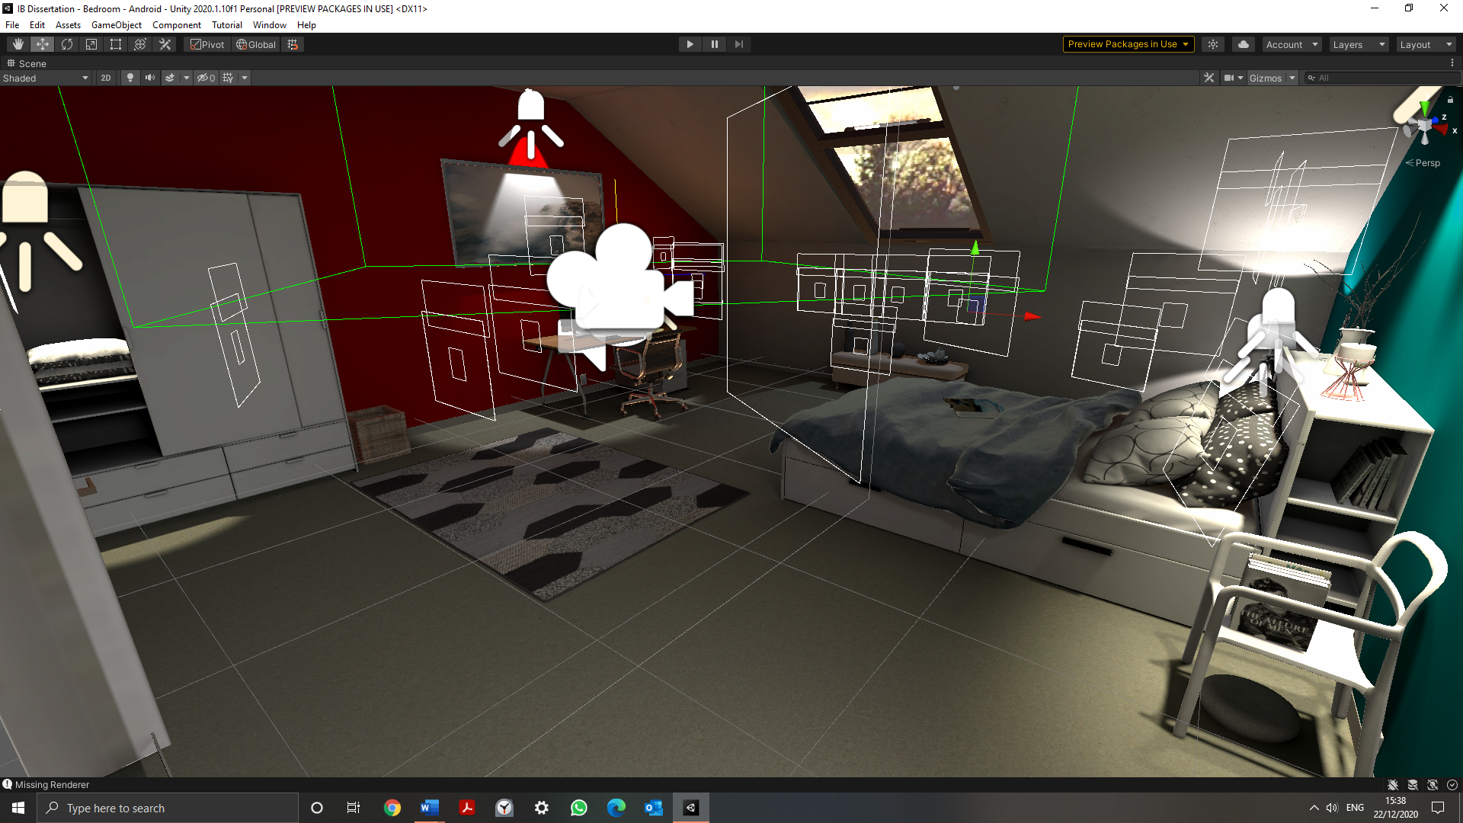

Adventure shopping stimuli:

In addition to catering the Application to both avoider and seekers on the pleasurable aspect, the Application design stresses on Adventure Shopping stimuli:

1. Bundling: Bundling refers to the placement of products in their intended environment. In this case furniture is placed bundled with other products, such as plates, cutlery etc. This will allow participants to explore the rooms content freely in an intuitive space
2. VR teleporting is enabled, this allows participants to roam freely in the rooms and explore them from any angle they like.
3. Every Object is interactable: furniture has a menu which when clicked displays information in the participant mother tongue as well as enable them to change the color and material of the object.

**Role Application:**

The role application is designed to provide participants with a neutral VR environment where they can browse a 3D catalogue of furniture. The goal of the Application is to create a setting where participants shop for furniture not for themselves, but for friends and or family members. This will be accomplished by introducing a setting whereby participants will be asked to browse items as gifts to close relatives or friends.

**Application design:**

The Application consists of VR menu that shows 3D furniture on command. The user is also able to rotate the object to inspect it but it has no control over colours and materials. The furniture is not bundled, but instead instantiated as is without any other furniture around. There is no store design as the Application is designed to be a catalogue not a store with a layout and presentation.

The setting is designed to test participants response when confronted with gift-giving a common form of role shopping. The store is also stripped of any adventure-driven design feature such as colours, music, VR teleporting exploration etc. to focus on Role shopping in isolation.

**The setting:**

The literature stress that role shopping is intimately connected to one’s social role. Role shopping is in fact grounded in role enactment theory and McGuire’s theory of human motivation. Gift-giving is considered to be a social duty in both Italian and Chinese culture and therefore this can be exploited in the experiment setting. In Chinese culture gift-giving is associated with …..

In Italian culture gift-giving is particularly associated with Christmas festivities…

**Tasks:**

**Adv**

**Role**

**Interviews: Why in-depth:**

The study will use semi- structure in-depth interviews. As presented in (research methods), the choice of using semi-structured in-depth interviews lies on four variables:

* **Purpose of the research:**

The study can be categorised as a partially exploratory study: although a critical framework has been established by Reynolds et a. 2003. Cross-Cultural VR retailing context is entirely unexplored. As such the study inevitably will have some exploratory characteristic.

As noted by () Studies that are exploratory or contain some exploratory elemen will benefit from using semi-structured or even in-depth interviews. In this case unstructured interviews are too informal and it runs the risk of losing focus(source). However, semi-structured will provide with some basic theme taken from the literature, but at the same time allow the interviewee and interviewr to explore more VR-focused questions as they may arise.

* **Establishing rapport**

Other data collections methods such as questionnaires are unreliable when dealing with more personal and complex issues. In particular, in the Role Application experiment, delicate social themes such as gift-giving will be introduced. Semi-structured interviews allow the participant to clarify himself more extensively than in short structured and highly focused questions, which will be important when trying to understand personal shopping motivations.

**Issues:**

**Generalisability:**

One of the issues raised against sem-structured interviews is that the sample size does not allow for certain generability. This is usually the case because the small sample size coupled with a difficult to reproduce environment will realistically be difficult to apply to the majority of cases. However the study main proposition is backed by the literature review in other contexts outside of VR. The study thus aims at applying such literature to a new retail environment : Virtual Reality while at the same time maintaining theoretical significance outside of the few selected cases by the study.

**Interview process:**

**Information given:**

**Interviewee will be given a list of themes derived from the literature to review before the experiment. This information will be given to participans in the Information Sheet. Providing themes before and interview can be beneficial in validating the study as interviewees will know beforehand what kind of information the experiment seeks to find.(main book methods )This will also help semi-structured interviews to have a focus on the topic that concers the research question.**

**Place:**

**The location of the experiment will be the researcher’s private accommodation. The experiment requires a 2X2 meters space to take place as the VR rig will have to used as well as a computer to observe the participants in the virtual environment.**

**Questions:**

**Questions will be based on the three RQs described in the methodology:**

**RQ1) Does VR enhance hedonic shopping motivations?**

To elucidate on this questions both the control group and the treatment group will be asked questions regarding their attitude towards shopping. I particular in the control the focus will be if they view shopping as utilitarian or if instead they have hedonic motivations to go shopping in the tradition retail sector. The treatment group will be asked instead if the VR tool has enhanced their motivation to shop for the excitement, fun etc. A comparison between the two groups will yield a conclusion on the RQ

**RQ2) Do Individualistic countries prefer Adventure shopping over Role? RQ3) ) Do Collectivistic countries prefer Adventure shopping over Role?**

The control group will be asked if they prefer adv or role in tradition retail environment.

The treatment group will be asked if they view VR tool as more adapt to role or adv.

From these questions the study will elucidate how shoppers’ hedonic motivations change VR environment and from the comparison of the Collectivistic group and the Individualistic group a preference for adventure or role shopping should emerge in the VR environment.